Augustus Mendy

Southern New Hampshire University

CS-330-11661-M01

Eugenio Rodriguez

January 12, 2025

## 2-3 Milestone One Project Proposal

I decided to work on the picture down below:

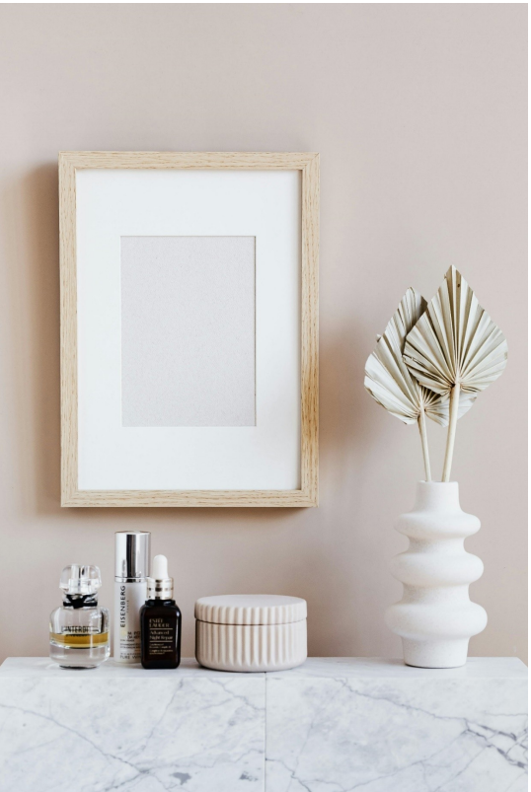

Objects for replication:

* Picture Frame: Easy-to-model basic rectangular forms
* Vase with Leaves: The leaves and the vase both have intriguing shapes.
* Perfume Bottle: Something tiny and intricate that will test your accuracy
* Skincare Bottle: A cylinder-shaped with a basic cap
* Surface (table): a level surface on which to place everything.

**Basic 3D shapes to use and the explanation of choices:**

|  |  |  |
| --- | --- | --- |
| **Objects** | **3D shapes** | **Explanation** |
| Picture Frame | The frame box.  The plane for the interior photo | A box shape is perfect for the frame, and a plane can be used for the picture inside, providing a clear structure. |
| Vase with Leaves | The vase's cylinder is tapered.  For the leaves, use a plane or prism. | A tapering cylinder can be used to create the vase's distinctive shape. To capture the flat yet structured appearance of the leaves, planes or prisms can be used. |
| Perfume Bottle | The top is a sphere. The body's cylinder | The key forms of the perfume bottle are captured by using a cylinder for the body and a spherical for the top. |
| Surface (table) | Plane | The table surface will be a straightforward plane that grounds everything. |